**Programme**

|  |  |  |
| --- | --- | --- |
| **Day 1: Friday 10th May 2024** | | |
| 1.00pm-1.30pm | Introduction to the day and the patient experience of acute disturbance | Jules Haste & Bernard Fox |
| 1.30pm – 2.00pm | Restrictive practice legal, ethical issues and de-escalation techniques | Laura Woods |
| 2.00pm – 3.00pm | Evidence for the use of oral and IM RT medication in acute disturbance. Including time for Q&As | Caroline Parker |
| 3.00pm – 3.30pm | Pharmacokinetics of oral and IM RT medicines | Jules Haste |
| 3.30pm – 3.45pm | **TEA BREAK** | |
| 3.45pm – 4.15pm | Use of oral and RT medication in special populations  Including time for Q&As   * Children and Adolescents * Older age and frailty including dementia | Beryl Navti |
| 4.15pm – 5pm | Clinical scenarios | Caroline Parker & Jules Haste |
| **Day 2: Friday 17th May 2024** | | |
| 1.00pm - 1.30pm | Adverse effects and risks associated with medication used in acute disturbance (HDAT risks) | Jules Haste |
| 1.30pm – 2.30pm | Use of oral and RT medication in special populations  Including time for Q&As | |
|  | * Pregnancy | Caroline Parker |
| * Learning Disabilities | James McCarthy |
| * Pre-hospital and acute hospital settings | Jules Haste |
| 2.30pm - 3.00pm | Other interventions including the use of Acuphase for acute agitation | James McCarthy |
| 3.00pm – 3.15pm | **TEA BREAK** | |
| 3.15pm - 4.00pm | Clinical scenarios   * Practical scenarios including switching, next choice and the administration of medication. | Jules Haste, James McCarthy & Caroline Parker |
| 4.00pm - 4.45pm | * Monitoring of physical health, review of response and debriefing | Laura Woods |
| 4.45pm | Questions, summary & close | Jules Haste |

**Trainers**

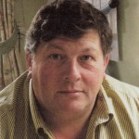***Bernard J. Fox***

Bernard suffered his first major psychotic episode in 2004. Sectioned, he spent time both in PICU and Acute care. Over three main admissions, Bernard has had direct experience of two PICUs and four Acute Wards. Since joining the NAPICU Executive Committee over a decade ago, Bernard has visited numerous PICUs across the country with NAPICU interest in mind. Bernard has been involved in NAPICU’s collaboration with BAP (Rapid Tranquillisation Guidance) Design in Mental Health and the NAPICU/RCPSYCH PICUS Accreditation scheme. Most recently assisting the UEA with Psychology training and examination.  Fervently pro uniform for Hospital settings he remains very keen to share his experience where it might help to improve Patient/Care providers outcomes and job satisfaction.

***Jules Haste***

Jules is the associate divisional director for pharmacy (West Sussex) and has worked in Mental Health since 1998. She trained at the University of Brighton and qualified as a pharmacist in 1995. She is an accredited College of Mental Health Pharmacists (CMHP) member and an independent prescriber. Jules leads on the intramuscular Mental Health section of Medusa, the Injectable Medicines Guide (IMG).

She is one of the authors on Joint BAP NAPICU evidence-based consensus guidelines for the clinical management of acute disturbance: De-escalation and rapid tranquillisation as well as the Royal College of Psychiatrists CPD Online module on Rapid tranquilisation of the acutely disturbed patient.

Jules believes that multidisciplinary working can ensure safe, effective and patient-centred care of patients. Her special interests include rapid tranquillisation, psychosis, bipolar affective disorder and meaningful conversations with patients about medicines.

**Trainers**

***Laura Woods***

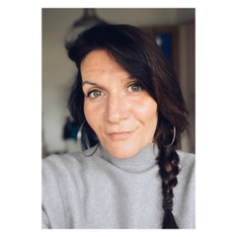Laura is a mental health nurse with over 18 years’ experience working in PICUs, prisons and secure and forensic health care. During her time working within PICU she was an active member of the Positive and Safe network for the Department of Health with her ward being an early implementer for reducing restrictive practice. Laura has spoken nationally about reducing the use of seclusion and has a particular interest in how PICU teams can provide meaningful alternatives to restrictive interventions.

After nearly nine years working in PICU, Laura managed a healthcare service within the prison estate. During this time, she gained a MSc in Clinical Forensic Psychiatry with her research looking at prison transfers to general adult PICUs.

She is now working as a Consultant Nurse and Approved Clinician on a women’s medium secure unit for Forensic Health Care in Sussex. Laura continues to focus on promoting mental health nursing as a clinical career, with her work focusing on the nurse-patient relationship. She remains committed to reducing restrictive practices across all mental health settings and consults on clinical practice in both secure services and PICU’s. Laura also enjoys teaching both pre-registration nursing students and on master’s programs at two different universities in the southeast. She is on the editorial board for the Journal of Psychiatric Intensive Care Units and is passionate about supporting nurses undertake research.

***Caroline Parker***

Caroline has worked as a specialist mental health pharmacist across a wide range of psychiatric services delivering direct patient care mostly in several central London hospitals and now in Gloucestershire.

Caroline was the Consultant Pharmacist for Adult Mental Health in Central and North West London NHS Foundation Trust from 2007 until 2020. She is a qualified Independent Non-medical Prescriber. In Gloucestershire she is the Lead pharmacist for Community Mental Health teams.

She served on the National Association of Psychiatric Intensive Care Units (NAPICU) executive committee between 2008-2019, latterly as the Director of Operations.

She is a Fellow of the College of Mental Health Pharmacy (CMHP), an accredited Faculty Fellow of the Royal Pharmaceutical Society, a Fellow of the Royal Pharmaceutical Society, and is on the editorial board of the International Journal of Psychiatric Intensive Care.

**Trainers**

***James McCarthy***

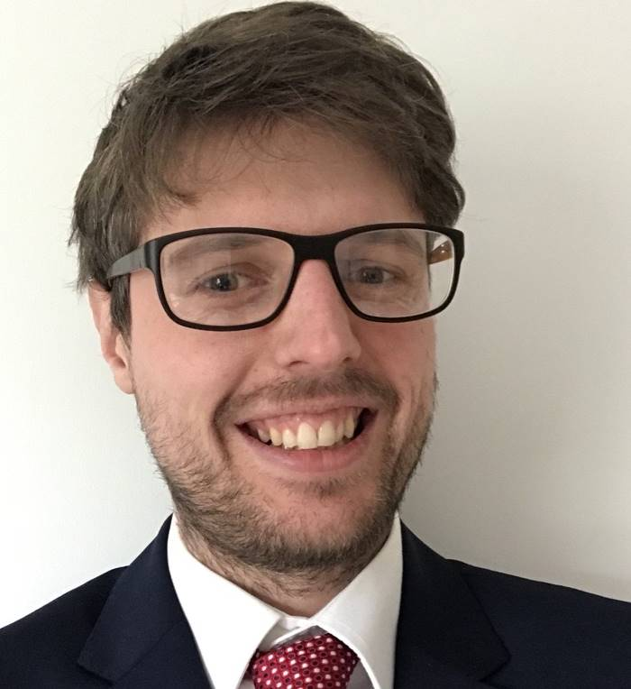James is a specialist mental health pharmacist with 10 years’ experience working across a variety of services including learning disability, medium & low secure, PICU and adult acute psychiatric inpatient wards. Currently working as a Clinical Pharmacy Manager for inpatient services at Devon Partnership NHS Trust, James leads a fantastic team of Clinical Pharmacists who support patients across 20 inpatient wards. James is passionate about education and has used his expertise to assess course work and provide lectures for undergraduate nurses and postgraduate pharmacists at a number of universities in the South West. James has a special interest in helping those with acute and complex psychiatric needs.

***Beryl Navti***

Beryl is the clinical lead pharmacist for Child and Adolescent Mental Health Services (CAMHS) in North East London Foundation Trust and having been appointed as a consultant pharmacist, she is currently completing the RPS consultant pharmacist credentialing pathway.

Her role is to develop clinical pharmacy services for CAMHS, working closely with the wider multidisciplinary team to promote safe prescribing, support medicines governance and advise on medicines optimisation for children with mental health needs.

Beryl has over 22 years experience in pharmacy practice spanning community, hospital, academic and mental health sectors. Over the years, she completed a PhD, master’s degrees in pharmaceutical technology and clinical pharmacy as well as the certificate in psychiatric therapeutics and the diploma in psychiatric pharmacy.

Beryl has worked with the Centre for Postgraduate Pharmacy Education (CPPE) to develop course content for the culturally competent communication e-learning programme and to review course content for their mental health e-learning modules. She is an executive member of the National Association of Psychiatric Intensive Care Units (NAPICU) as well as a credentialed member of the College of Mental Health Pharmacy (CMHP) and is keen to be involved with developing pharmacists and pharmacy technicians fit for the future.

Outside of work, Beryl is involved in working with various charities contributing to community development projects in Africa.